EXPERIMENT 06
ENUMERATE WEB SERVER INFORMATION

1. AIM
To perform deep enumeration on a web server—identifying allowed HTTP methods, exposed directory trees, robots.txt contents, and SSL/TLS configuration parameters.

2. THEORY
Enumeration actively probes web server configurations to discover exposed entry points.
Misconfigurations—such as open directory browsing, dangerous HTTP methods (PUT, DELETE, TRACE), or weak SSL ciphers—can expose sensitive files even on patched servers.

3. TOOLS REQUIRED
- Nmap NSE
- curl & openssl CLI
- Gobuster / DirBuster
- Browser

4. PROCEDURE & COMMANDS
Step 1: Enumerate Allowed HTTP Methods
Test server support for dangerous methods like OPTIONS, PUT, DELETE, and TRACE:
curl -X OPTIONS -i http://<target-ip>
nmap -p80 --script=http-methods <target-ip>

Step 2: Inspect Crawling Directives (robots.txt & sitemap.xml)
Retrieve hidden path declarations from web crawler directive files:
curl http://<target-ip>/robots.txt
curl http://<target-ip>/sitemap.xml

Step 3: Execute Directory & File Brute-Forcing with Gobuster
Scan for hidden directories and backup files using a standard wordlist:
gobuster dir -u http://<target-ip> -w /usr/share/wordlists/dirb/common.txt

Step 4: Audit SSL/TLS Cipher Suites and Protocols
Evaluate HTTPS security configurations for weak SSLv3/TLS1.0 protocols:
openssl s_client -connect <target-ip>:443
nmap -p443 --script=ssl-enum-ciphers <target-ip>

5. LAB OBSERVATIONS & OUTPUT SCREENSHOTS
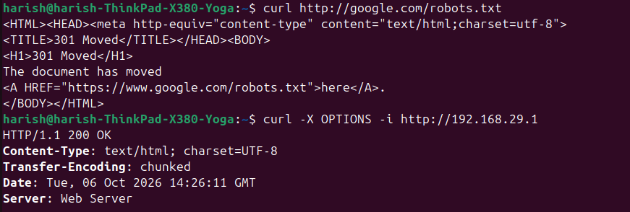

6. EXPECTED OUTPUT RESULT
An enumeration report documenting enabled HTTP methods, discovered unlinked directories (e.g., /admin, /backup), robots.txt disallow lists, and SSL/TLS cipher evaluations.

7. VIVA VOICE QUESTIONS & ANSWERS
S.NO & VIVA QUESTION | TECHNICAL ANSWER
Q1. What is the difference between reconnaissance and enumeration? | Reconnaissance discovers target assets and open ports. Enumeration actively queries services to extract specific account names, shares, and directory paths.
Q2. Why is the TRACE HTTP method considered risky if left enabled? | TRACE echoes back client requests, allowing attackers to perform Cross-Site Tracing (XST) to capture HttpOnly session cookies.
Q3. Why can robots.txt actually help an attacker instead of protecting the site? | It explicitly lists sensitive directories (e.g., /admin, /backup) that site owners want hidden from search engines.
Q4. What does Gobuster do, and what does a wordlist contain? | Gobuster brute-forces directory and file names on web servers using a text wordlist containing thousands of common path names.
Q5. Name one weak SSL/TLS configuration and why it is a problem. | Supporting SSL 3.0 or TLS 1.0, which contain cryptographic flaws vulnerable to attacks like POODLE.

